  L2 FA24

Q1:

Software Requirements Specification

for

Software Requirements Specification

for

FU Event Management (FUEM)

Version 1.0 approved

Prepared by : Kyuumei Neko

FPT University Ha Noi

18/11/2024

Q2:

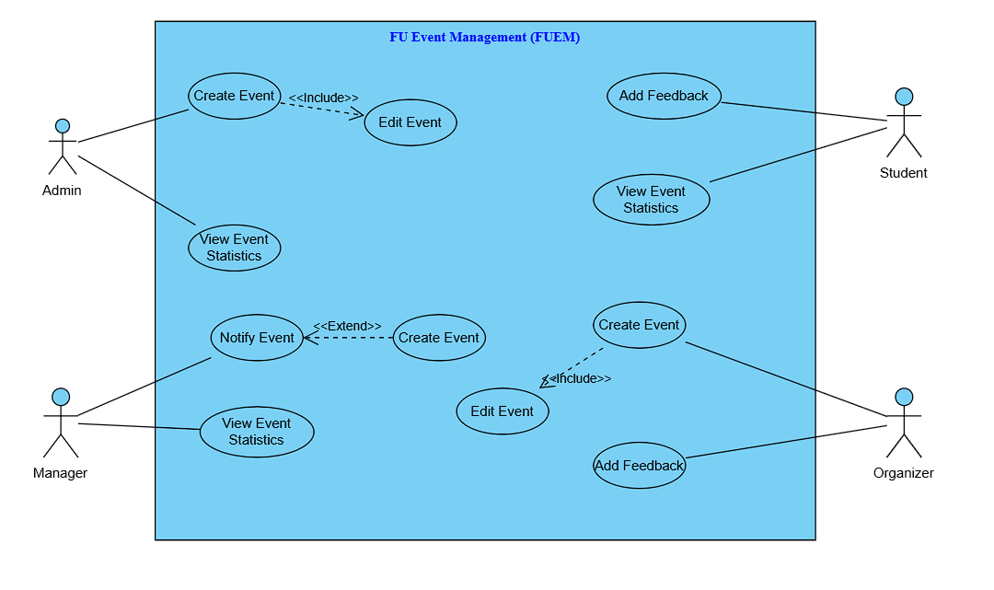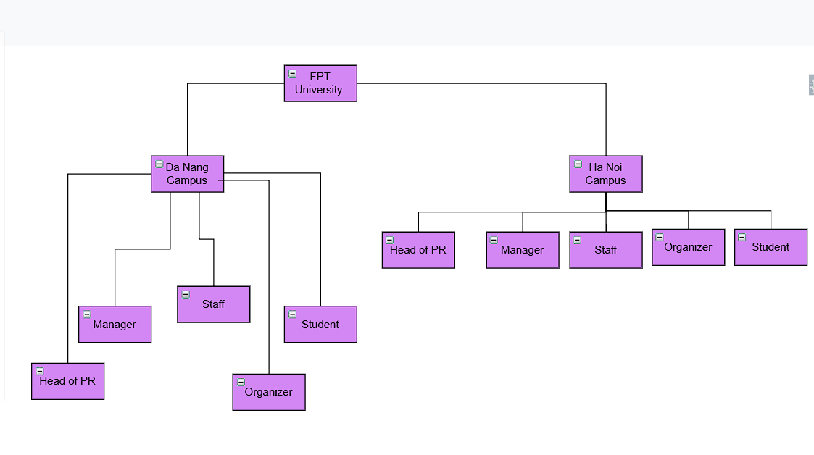Q3:

1.Drawing from the rest of the exam paper, the name of the rectangled feature is:

FU Event Management System

1. The actor may be human or may belong to other software systems or devices. In this exam paper, list the following actors’ names: >= 4 actors’ names should be provided:

Admin, Manager, Organizer, Student

3.In this exam paper, list the following use cases: >= 5 cases should be listed:

Create Event, Edit Event, Notify Event, Add Feedback, View Event Statistics

4.The actors are inside or outside the rectangle?

Outside

5.The ovals represent the use cases are inside or outside the rectangle?

Inside

6.The primary actor of the use case ‘create event’ is:

Admin

7.The secondary actor of the use case ‘create event’ is:

Organizer

8.Based on the fact that you have snowballed with Event Management website, one may expect the use cases in this electronic exam paper to be so related. For instance: In the case of events: a. List the name of two use cases which have extend relation with event management system:

Notify Event – Intercept Event – Create Event

b. The name of the use case on which the other five, in 8.a above is built is:

Create Event

c. The name of the use case which is in 8.a. above called extend use case is:

Notify event

d. The dashed line with an arrow is used to show direction to which event:

Create Event

9.Since you are already familiar with the Event Management website, the use cases in this exam paper may have include relationships.

a. List the name of two use cases which have include relationship: Create Event -> Edit Event

b. The name of the base use case (in 9.a) is: Create Event

c. The name of the included use case (in 9.a) is: Edit Event

d. The dashed line with arrow indicates direction to which use case? Edit Event

Q4:

< Student must replace this line, answer of Q4 by filling the content into the below table that reflects this exam paper. NOTE: Student must remove the guideline in and after the (….).>

|  |  |  |  |
| --- | --- | --- | --- |
| UC ID and Name: | UC-1 Create Event | | |
| Created By: | Kyuumei Neko | Date Created: | 18/11/2024 |
| Primary Actor: | Admin | Secondary Actors: | Organizer |
| Trigger: | In the system, a new event is to be created. | | |
| Description: | Fulfilling this use case involves working with the FU event management system with the aim of creating an event. | | |
| Preconditions: | 1. System administration has given permissions to log in and manage the system. 2. The system is switched on and is ready to receive input processing.… | | |
| Post conditions: | 1.The event is correctly recorded in the database and can be retrieved later on.  2.All the people who have been authorized to view the event can see its details. | | |
| Normal Flow: | 1.The admin opens FUEM system through the username and password he/she has been provided with.  2.The “Create Event” page is accessed by the admin.  3.He/she inserts information about the event in the section provided (title, date, time, area, and details of the event).  4.Necessary documents and media files are uploaded.  5.The data is entered and the creation is validated by an admin.  6.An event has been created in the system and its details have been saved in the database. | | |
| Alternative Flows: | 1.Since some information about the event must be provided, an Admin is requested to provide this information as opposed to leaving it bare.  2.Should the case be where the files uploaded to the website are too large and exceed a maximum storage requirement, the website would, for the sake of professionalism and proper management, deny posting the files and suggest other options.  3.Should there be an overlapping event in the calendar, the system shall alert the Admin with the option of moving the event to another date. | | |
| Exceptions: | 1.If the system is offline, the Admin receives an error message indicating unavailability.  2.If the database fails to save the event, the system notifies the Admin to try again later.  3.If the Admin session times out, they are redirected to the login page. | | |
| Priority: | High | | |
| Frequency of Use: | Daily | | |
| Business Rules: | 1.The event name must be unique.  2.The event date must not be in the past.  3.Only authorized Admins can create events. | | |
| Other Information: | The system should ensure that the created event is synchronized across all devices in real time. | | |
| Assumptions: | 1.The Admin has sufficient permissions to create events.  2.The system clock is correctly synchronized to avoid date/time issues. | | |

**Q5:**

a. Non-functional Requirement 1: Performance

The system should support up to 100 simultaneous users without any performance degradation, that is a single user and 99 other users accessing the website at the same time.

With five butts in chairs loading pages is not going to take more than 2 seconds and once the work load equals to 50 users, with big enough database data should not be dumped for more than 2 seconds.

b. Non-functional Requirement 2: Security

All sensitive data, like event details or the password for the system, should be stored encrypted using the AES-256 algorithm.

Administrative tasks in the system can only be performed by logged system users: Admin, Manager, Organizer, after they will pass 2FA verification.